2016

Two Trains documentary focuses on impact of ice in Circular Head
Drugs, addiction and their impact on the community was the basis for a documentary produced by a group of students from Circular Head.
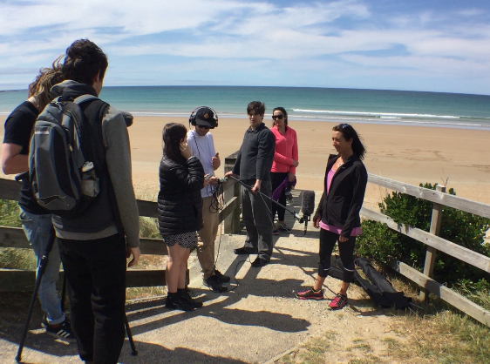
In October 2014, Smithton was under the spotlight for its methamphetamine (ice) epidemic.
At the time it was estimated that up to 10 per cent of the population in the small Tasmanian town were using ice.
With the help of an FRRR ABC Heywire Youth Innovation Grant, Rural Health Tasmania engaged a group of high school students who banded together to make a documentary about the impact ice was having on their tight-knit community.
"The ripple effect creates an environment where you feel really scared and you don't know what to do ... and that was what the film was about - getting people to talk about this instead of hiding at home." (19 yo Jobi Starick)
Two Trains featured stories about drug addiction and recovery from the local community.
The film was launched in Smithton in November 2016.
A crowd of more than 120 spilled from the local youth centre - more people than the venue had seats for.
"We had people of all ages, young and old," Jobi said.
"Lots of people came to support us, lots of people came to thank us and lots of people just came to watch and really take in the fact that kids had created something in the community that was going to spark change."
The film can be viewed in full here. ….. Two Trains - one community's response to the ice epidemic
